Project 3 : Azure Data Engineering
ADF+ADLS+DATABRICKS+ POWER BI

Business Requirements
- We have to build end to end data pipeline for the retail clients.
- We have data coming from multiple sources and we need to bring the data into data lake.
- We have transaction data, store data and product data available on Azure SQL DB.
- We have customer data coming from API Json format

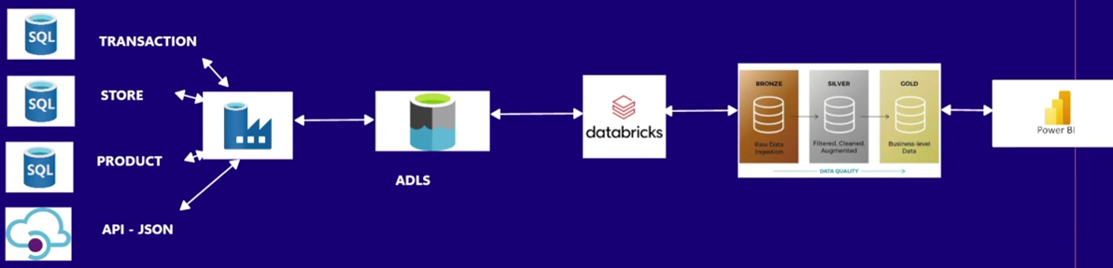

SQL Tables
CREATE TABLE products (
product_id INT PRIMARY KEY,
product_name VARCHAR(100),
category VARCHAR(50),
price DECIMAL(10,2)
);

INSERT INTO products VALUES
(1, 'Wireless Mouse', 'Electronics', 799.99),
(2, 'Bluetooth Speaker', 'Electronics', 1299.49),
(3, 'Yoga Mat', 'Fitness', 499.00),
(4, 'Laptop Stand', 'Accessories', 999.99),
(5, 'Notebook Set', 'Stationery', 149.00),
(6, 'Water Bottle', 'Fitness', 299.00),
(7, 'Smartwatch', 'Electronics', 4999.00),
(8, 'Desk Organizer', 'Accessories', 399.00),
(9, 'Dumbbell Set', 'Fitness', 1999.00),
(10, 'Pen Drive 32GB', 'Electronics', 599.00);

-- Stores Table
CREATE TABLE stores (
store_id INT PRIMARY KEY,
store_name VARCHAR(100),
location VARCHAR(100)
);

INSERT INTO stores VALUES
(1, 'City Mall Store', 'Mumbai'),
(2, 'High Street Store', 'Delhi'),
(3, 'Tech World Outlet', 'Bangalore'),
(4, 'Downtown Mini Store', 'Pune'),
(5, 'Mega Plaza', 'Chennai');

-- Transactions Table
CREATE TABLE transactions (
transaction_id INT PRIMARY KEY,
customer_id INT,
product_id INT,
store_id INT,
quantity INT,
transaction_date DATE,
FOREIGN KEY (product_id) REFERENCES products(product_id),
FOREIGN KEY (store_id) REFERENCES stores(store_id)
);

INSERT INTO transactions VALUES (1, 127, 8, 4, 4, '2025-03-31');
INSERT INTO transactions VALUES (2, 105, 3, 4, 5, '2024-11-12');
INSERT INTO transactions VALUES (3, 116, 2, 2, 3, '2025-05-01');
INSERT INTO transactions VALUES (4, 120, 8, 1, 1, '2024-11-02');
INSERT INTO transactions VALUES (5, 105, 5, 2, 1, '2025-03-17');
INSERT INTO transactions VALUES (6, 110, 7, 3, 5, '2025-01-04');
INSERT INTO transactions VALUES (7, 110, 7, 2, 5, '2025-01-01');
INSERT INTO transactions VALUES (8, 126, 7, 5, 2, '2025-06-08');
INSERT INTO transactions VALUES (9, 123, 1, 3, 2, '2024-10-08');
INSERT INTO transactions VALUES (10, 124, 2, 2, 5, '2024-08-27');
INSERT INTO transactions VALUES (11, 102, 1, 3, 2, '2024-08-11');
INSERT INTO transactions VALUES (12, 108, 5, 1, 4, '2025-05-26');
INSERT INTO transactions VALUES (13, 104, 3, 3, 4, '2025-05-04');
INSERT INTO transactions VALUES (14, 120, 1, 4, 5, '2024-07-17');
INSERT INTO transactions VALUES (15, 121, 6, 5, 5, '2025-05-19');
INSERT INTO transactions VALUES (16, 118, 6, 2, 4, '2024-11-29');
INSERT INTO transactions VALUES (17, 109, 8, 5, 5, '2024-07-10');
INSERT INTO transactions VALUES (18, 103, 1, 4, 3, '2024-09-05');
INSERT INTO transactions VALUES (19, 116, 8, 4, 4, '2024-07-14');
INSERT INTO transactions VALUES (20, 130, 5, 1, 2, '2024-07-30');
INSERT INTO transactions VALUES (21, 105, 1, 3, 5, '2024-10-02');
INSERT INTO transactions VALUES (22, 107, 9, 3, 4, '2024-11-16');
INSERT INTO transactions VALUES (23, 122, 9, 4, 2, '2025-04-30');
INSERT INTO transactions VALUES (24, 125, 1, 5, 1, '2024-07-14');
INSERT INTO transactions VALUES (25, 116, 8, 4, 5, '2024-12-13');
INSERT INTO transactions VALUES (26, 126, 6, 2, 2, '2024-09-21');
INSERT INTO transactions VALUES (27, 127, 8, 1, 1, '2024-10-10');
INSERT INTO transactions VALUES (28, 101, 7, 5, 3, '2024-11-15');
INSERT INTO transactions VALUES (29, 119, 9, 4, 2, '2025-06-03');
INSERT INTO transactions VALUES (30, 116, 8, 4, 5, '2025-03-16');

Project Set Up
- Azure SQL DB
  - Transaction in parquet file format
  - Store in parquet file format
  - Product in parquet file format

- API – git hub customers Data-Engineering-/Azure Notes/customers.json at main · teena-akumenbyq/Data-Engineering-

- ADLS Containers retail bronze, silver, gold. In bronze upload raw files (4 files)
- Silver clean
- Gold to power Bi

